
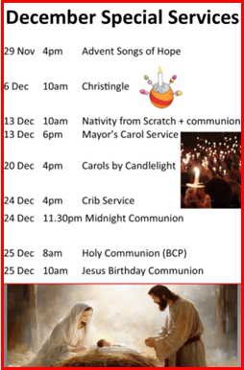
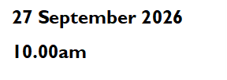
Sidespeople: Graham, Martin, Sandy and Val
Leader: John Seabridge

The Gathering
Welcome
Hymn 109 Crown Him with many crowns
Prayer of Preparation Pg 2
The Confession
Gloria
Collect 17th Sunday after Trinity
The Ministry of the Word
Exodus 17.1-7 Pg 75 Lynn Seabridge
Romans 5.6-11 Pg 1132 Ali Saunders
Hymn 795 You laid aside your majesty
Luke 24.33-53 Pg 1061 Mike Saunders
Sermon Mike Saunders
Creed Pg 4
Intercessions Stella Coulthurst
The Ministry of Communion
The Peace
Collection Hymn 511 O Lord, Your tenderness
Eucharistic Prayer A Pg 7
The Lord’s Prayer Pg 9
Breaking of the Bread and Giving of Communion
HC Assists: Rebecca Mangham & Neale Marney
Prayer after Communion Pg 10
The Sending Out
Notices
Refreshments after the 10am service will be served by
Val Troke and Daniel Martin
Do please stay and join us
Hymn 796 You shall go out with joy
The Blessing & Dismissal
Prayer Ministry after the service
Led by Mike Saunders and Julie Turner
Welcome to

27 September 2026

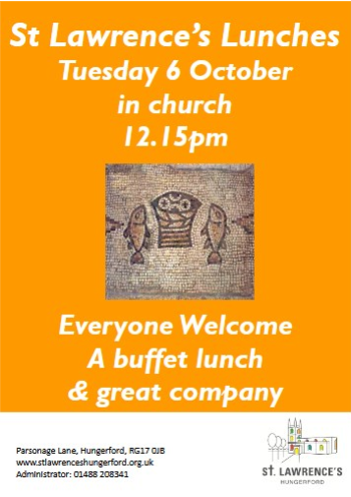
[Grab your reader’s attention with a great quote from the document or use this space to emphasise a key point. To place this text box anywhere on the page, just drag it.]

Contact Details
Rev Mike Saunders (Vicar) 01488 208341
vicar@stlawrenceshungerford.org.uk

George Ham (Churchwarden) 01488 684121
wardens@stlawrenceshungerford.org.uk

Janet Cole (Churchwarden) 07906 401687
janet10jan@gmail.com

Aeron Slade (Children & Youth Minister) 07453 866326
aeron@stlawrenceshungerford.org.uk

8am Holy Communion (BCP)
27 September 2026
17th Sunday after Trinity
Sidesperson: Catherine Wooliston Pg 184

