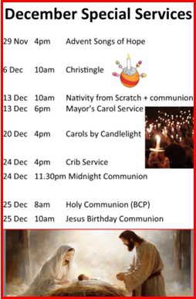



25 October 2026
10am
Sidespeople: Graham Jones and Martin Crane
Leader: Ali Saunders

The Gathering
Welcome
Hymn 224 He who would valiant be
Prayer of Preparation Pg 2
The Confession
Gloria
Collect Bible Sunday
The Ministry of the Word
2 Samuel 9 Pg 312 Rebecca Mangham
Colossians 3.12-17 Pg 1184 Alastair Campbell
Hymn 757 When peace like a river
Matthew 22.34-end Pg 993 Mike Saunders
Sermon Mike Saunders
Creed Pg 4
Intercessions Charlotte Kaye
The Ministry of Communion
The Peace
Collection Hymn 1261 Brother, sister let me serve you
Eucharistic Prayer A Pg 7
The Lord’s Prayer Pg 9
Breaking of the Bread and Giving of Communion
HC Assists: Graham Jones & Rebecca Mangham
Prayer after Communion Pg 10
The Sending Out
Notices
Hymn 705 Thy hand O God has guided
Refreshments after the 10am service will be served by
Jeanne Lambourn and Charlotte Kaye
Do please stay and join us
The Blessing & Dismissal
Prayer Ministry after the service
Led by Ali Saunders & Steve Powell
Welcome to

25 October 2026

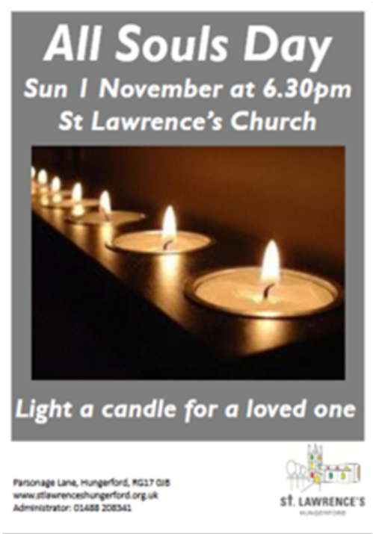



Contact Details
Rev Mike Saunders (Vicar) 01488 208341
vicar@stlawrenceshungerford.org.uk

George Ham (Churchwarden) 01488 684121
wardens@stlawrenceshungerford.org.uk

Janet Cole (Churchwarden) 07906 401687
janet10jan@gmail.com

Aeron Slade (Children & Youth Minister) 07453 866326
aeron@stlawrenceshungerford.org.uk

8am Holy Communion (BCP)
25 October 2026
21st Sunday after Trinity
Sidesperson: Catherine Wooliston Pg 190

