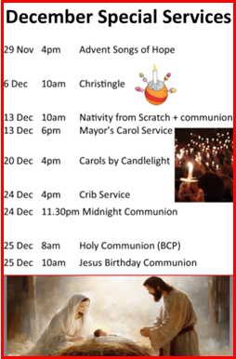



1 November 2026
10am
Sidespeople: Henry and Betty Jefferies
Leader: Charlie Morecroft

The Gathering
Welcome
Liturgical Greeting
Hymn MP 148 For all the saints
The Confession
Gloria
Collect for All Saints Day
Hymn This little light of mine

The Ministry of the Word
Matthew 5.1-12 Pg 968
Sermon Mike Saunders
Creed
Collection Hymn For all the saints
Intercessions Ali Saunders
Lord’s Prayer

The Sending Out
Notices
The Grace
Hymn O when the saints
Activities after the service are in St Lawrence’s Room at the back of church

Refreshments after the 10am service will be served by
Jane Wood and Ali Saunders
Do please stay and join us

Welcome to

1 November 2026

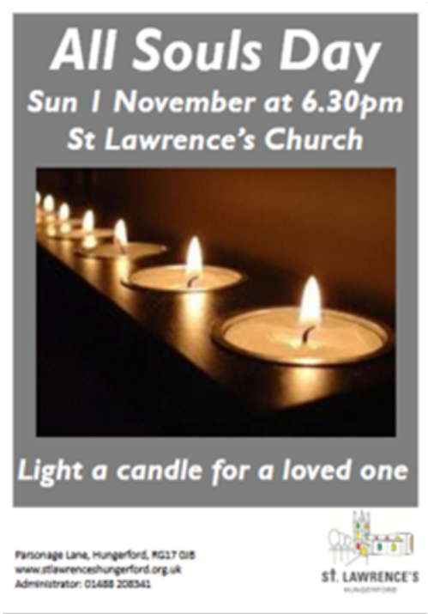




Contact Details
Rev Mike Saunders (Vicar) 01488 208341
vicar@stlawrenceshungerford.org.uk

George Ham (Churchwarden) 01488 684121
wardens@stlawrenceshungerford.org.uk

Janet Cole (Churchwarden) 07906 401687
janet10jan@gmail.com

Aeron Slade (Children & Youth Minister) 07453 866326
aeron@stlawrenceshungerford.org.uk

8am Holy Communion (BCP)
1 November 2026
All Saints Day
Sidesperson: Di Loft Pg 233

